**DAILY ONLINE ACTIVITIES SUMMARY**

|  |  |  |  |  |  |  |  |
| --- | --- | --- | --- | --- | --- | --- | --- |
| **Date:** | **10/06/2020** | | | | **Name:** | **Namratha C** | |
| **Sem & Sec** | **8th sem, A sec** | | | | **USN:** | **4AL16CS056** | |
| **Online Test Summary** | | | | | | | |
| **Subject** | | **No Test Conducted** | | | | | |
| **Max. Marks** | |  | | **Score** | |  | |
| **Certification Course Summary** | | | | | | | |
| **Course** | **Introduction to Amazon Virtual Private Cloud (VPC)** | | | | | | |
| **Certificate Provider** | | | **Aws training and certification** | **Duration** | | | **10mins** |
| **Coding Challenges** | | | | | | | |
| **Problem Statement: 1)**  **Python Program to find the L.C.M. of two input number** | | | | | | | |
| **Status: Completed** | | | | | | | |
| **Uploaded the report in Github** | | | | **Yes** | | | |
| **If yes Repository name** | | | | **CODES (Namrathasonu)** | | | |
| **Uploaded the report in slack** | | | | **Yes** | | | |

Online Test Details: **No Test Conducted**

Certification Course Details:

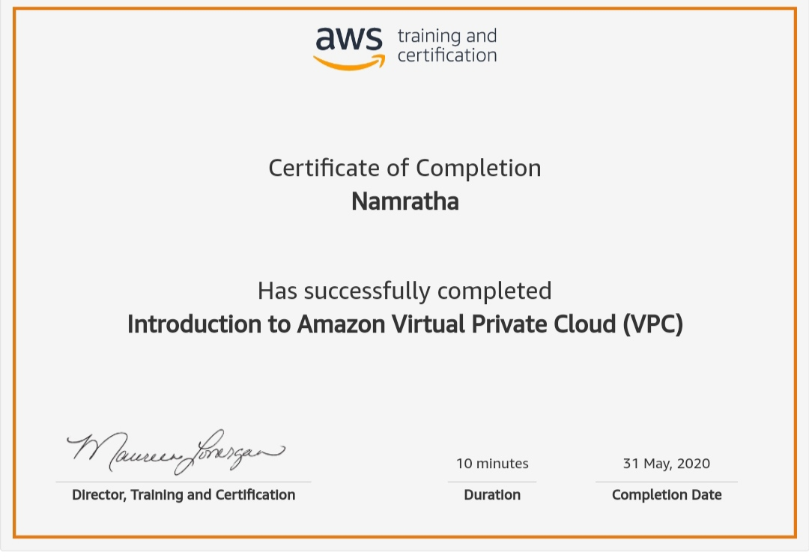

Coding Challenges Details:

1)

def compute_lcm(x, y):

# choose the greater number

if x > y:

greater = x

else:

greater = y

while(True):

if((greater % x == 0) and (greater % y == 0)):

lcm = greater

break

greater += 1

return lcm

num1 = 54

num2 = 24

print("The L.C.M. is", compute_lcm(num1, num2))